Webinar Swing Trading 2026

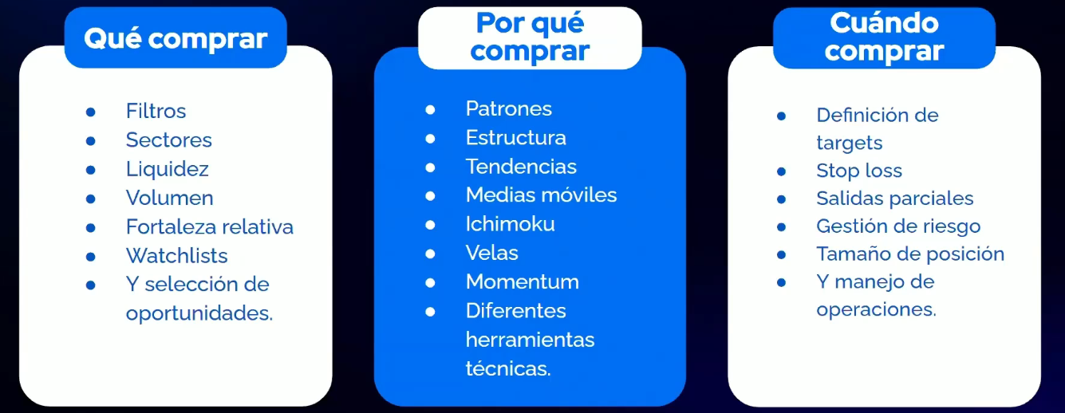

Glosario
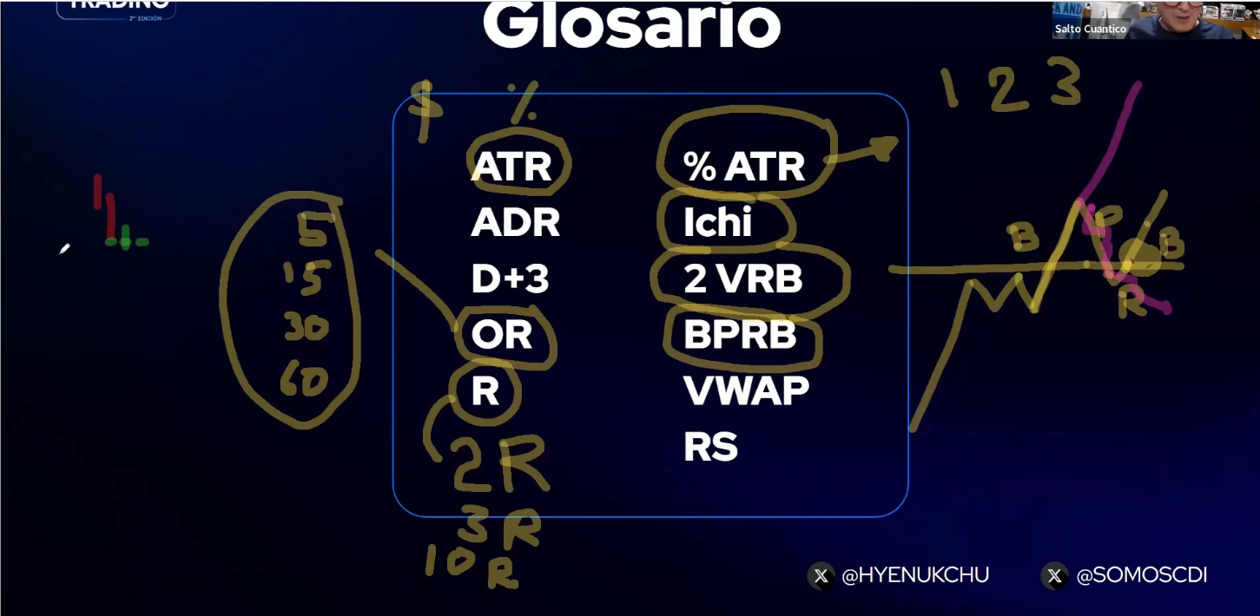

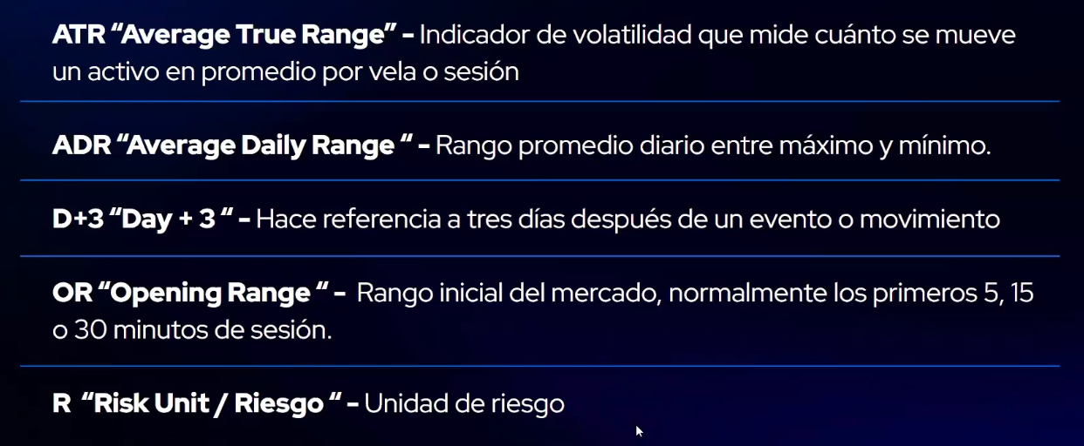
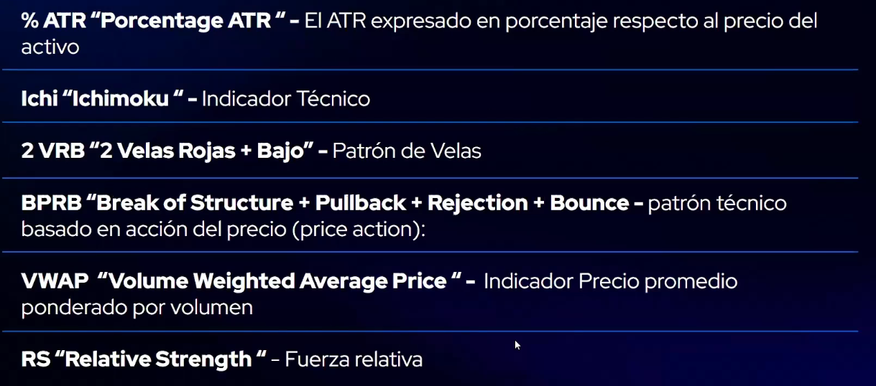

Filtros Finviz

Volumen climático:
https://finviz.com/screener?v=141&f=cap_smallover%2Cind_stocksonly%2Csh_curvol_o5000%2Cta_change_u%2Cta_changeopen_u%2Cta_perf_1wup&o=perf1w&preset=s151616253

Ganadores semanales:
https://finviz.com/screener?v=141&f=ind_stocksonlyspac%2Csh_avgvol_o100%2Csh_price_o5%2Cta_perf_1w20o&o=-perf1w&preset=s151616244

Momentum Trending:
https://finviz.com/screener?v=141&f=cap_smallover%2Cfa_epsqoq_o25%2Cfa_epsyoyttm_pos%2Cfa_netmargin_pos%2Cfa_roe_pos%2Cfa_salesqoq_o10%2Cfa_salesyoyttm_pos%2Cgeo_usa%2Cind_stocksonly%2Csh_avgvol_o100%2Csh_price_o10%2Cta_highlow52w_a50h%2Cta_sma20_sa50%2Cta_sma200_pa%2Cta_sma50_pa&o=-perf1w&preset=s151616223

Cómo creo los gráficos:
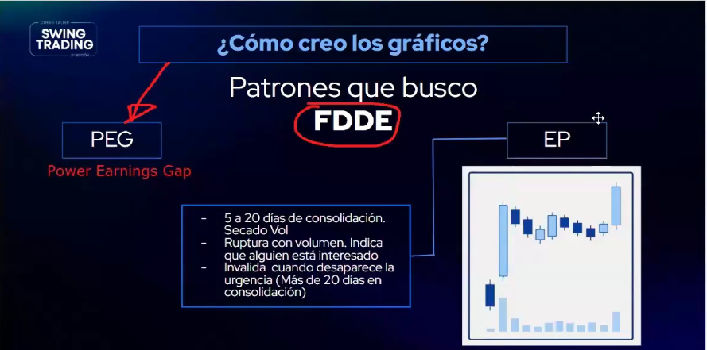

7 Pasos del BO

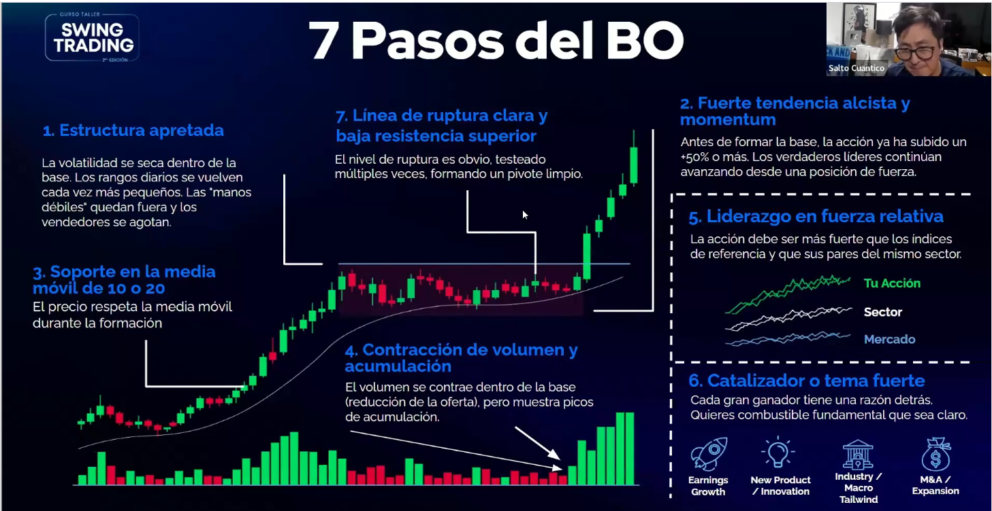

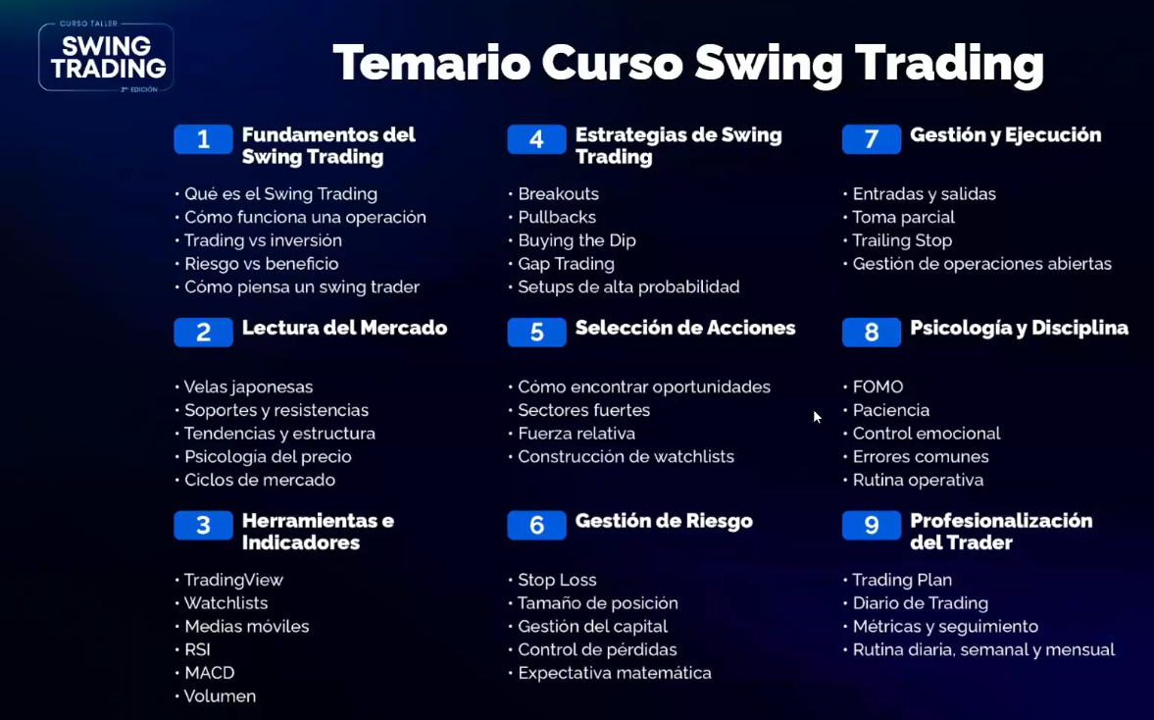

04:00:00

